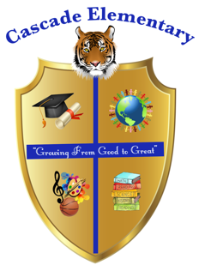

Cascade Elementary Website
Weekly Grade Level News Blast

Week of: Monday, April 20, 2020

Grade Level: Second Grade

Standards of the Week:
ELA: 2.RI.8: Describe how reasons support specific points the author makes in a text.

MATH: 2.OA.3: Determine whether a group of objects (up to 20) has an odd or even number of members, e.g., by pairing objects or counting them by 2s; write an equation to express an even number as a sum of two equal addends.

SCIENCE: S2P1: Obtain, evaluate, and communicate information about the properties of matter and changes that occur in objects.

SOCIAL STUDIES: SS2H1: Describe the lives and contributions of historical figures in Georgia history.

Additional Information for Parents and Students:

